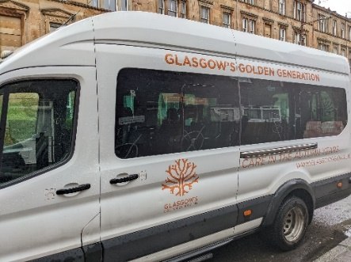

Title of Role: Volunteer Driver
Glasgow’s Golden Generation are a Charity in Glasgow who have been helping and supporting the older generation since 1948, offering vital services to ensure older adults have a better quality of life and allowing then to be socially included in their local communities by offering: Day Care Services, Befriending Services, Welfare and Income Maximisation Service, Weekly Social Clubs and Digital Services.

Purpose of the Role
The purpose of the role is to assist with the transportation of our clients from the front door of their property to the Day Centre. We transport service users either with one of our mini-buses or a people carrier.

Main Activities/ Tasks:
- Collecting and returning service users to their residences
- Assisting service user to and from the vehicle
- Supporting service users en-route to our centres
- To promote public understanding of the work carried out by Glasgow’s Golden Generation
- To promote and adhere to the policies and procedures in the Driver’s Handbook

Qualities/ Experience/Skills
- Experienced Driver
- Category D1 Licence required (only for minibus drivers)
- Good communication skills, reliability and customer care service skills are required to fulfil this role.
- You will need a full driving licence for at least two years, be over 21 years of age and have no points on your licence.

Hours from 9.30am to 11am and thereafter 2.30pm until the last drop off. Driving and pick-ups will be within the Glasgow area only.
What we offer:
- The chance to be part of an exciting team who will support and develop you with on-going training
- The opportunity to be involved with outings with our service users
- The chance to make a real contribution to Glasgow’s Golden Generation.

Please note that this post will be subject to a PVG background check.

Training and Support
Full in-house training will be given of operational procedures during your induction period

Locations
Fred Paton Day Centre, 19 Carrington Street, Glasgow G4 9AJ
Mattie Carwood Day Centre, 2 Hallhill Road, Glasgow G32 0LL
David Cargill Centre, 166 Ledard Road, Glasgow G42 9RA

Main Point of Contact
Naomi Bruce, Volunteer Coordinator
Email: naomi.bruce@glasgowgg.org.uk 07849700324

Karen Moyes, Engagement Volunteer Manager
Email: Karen.moyes@glasgowgg.org.uk 07538979427

